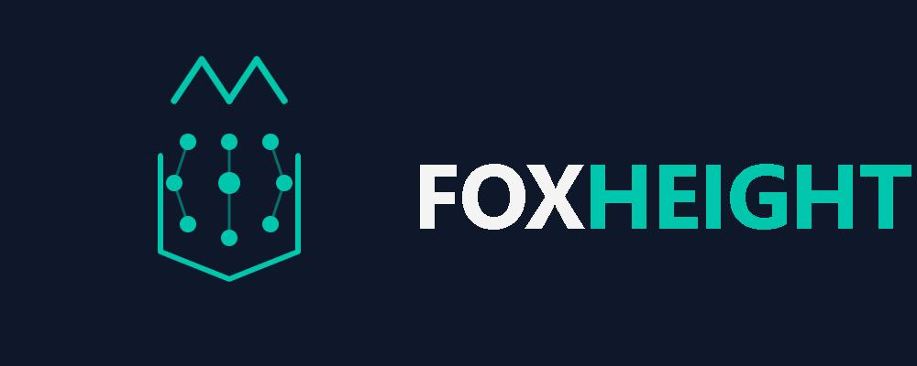
Fox Height Limited
From Equation to Civilization, and Back.
Company Profile
Eden Square, 7th Floor, Chiromo Road, Westlands, Nairobi, Kenya · Founded 2025

Executive Overview
Sovereign Cloud, AI Infrastructure and Continuum Architecture for East Africa and the world.
Fox Height Ltd is a Microsoft AI Cloud Partner headquartered in Nairobi, Kenya, building the FoxHeight Continuum platform — a twenty-product ecosystem spanning cloud infrastructure, AI orchestration, data governance, cybersecurity, and long-range systems research.

Mission & Engineering Principles
FoxHeight's public platform documentation states its purpose as: "Company identity, principles and East African context."

Principles
- Representation before computation
- Determinism where possible
- Explicit state and observability
- Least privilege and secure defaults
- Honest maturity labelling

Product Ecosystem
FoxHeight Continuum comprises 20 product lines, each carrying an explicit maturity label rather than a uniform claim of production readiness.
Product | Category | Maturity
FoxOS | platform | RESEARCH
FoxAI | intelligence | RESEARCH
FoxData | data | RESEARCH
FoxCloud | infrastructure | PRODUCTION-ADJACENT
FoxFlight | autonomy | CONCEPT
FoxShield | security | PROTOTYPE
FoxLink | network | RESEARCH
FoxEdge | infrastructure | RESEARCH
FoxLab | research | RESEARCH
Continuum | platform | RESEARCH
FoxInsight | intelligence | PROTOTYPE
FoxAuto | automation | CONCEPT
FoxSpace | spatial | CONCEPT
FoxQuantum | research | CONCEPT
FoxGreen | sustainability | CONCEPT
FoxBuild | infrastructure | CONCEPT
FoxKnow | knowledge | PROTOTYPE
FoxTwin | simulation | CONCEPT
FoxHuman | human | RESEARCH
FoxFuture | vision | 2050 VISION (CONCEPTUAL)

Platform Architecture

Local-first foundation
Architecture decision ADR-001 (Local-first architecture) records the context as East African connectivity and sovereignty constraints, with the decision to prefer local JSON/filesystem and offline-capable cores and to treat cloud as an optional plane — avoiding a mandatory external database.

Service boundary
Architecture decision ADR-002 (PHP/Node boundary) records that PHP owns pages, sessions and CMS functions, while Node owns ranking, search and audit intelligence APIs — a split chosen for clear failure isolation, at the cost of operating two processes.

Stack, as documented
Per the platform README: PHP 8.x + Node.js (standard library) + JSON + vanilla CSS/JS, local-first, with no required Composer or npm packages for the core to run.

Current State & Roadmap
Current release: FoxHeight Continuum v5.7.0 ("System Expansion"), build 2026.08.21-expand, channel production.
Latest recorded platform snapshot (2026-08-21T06:02:39+00:00): 20 products, 8 leads, 3 whitepapers on file, PHP runtime 8.3.6. Bounded evolution cycle. Not autonomous strategy change.

Leadership
Samson Mobisa — CEO and Founder, Fox Height LTD. Sole director building the company's partner and commercial infrastructure. Research/technical contact: mobisa@foxheight.com.

Contact
Eden Square, 7th Floor, Chiromo Road, Westlands, Nairobi, Kenya
General: info@foxheight.com · Research: mobisa@foxheight.com
foxheight.com

