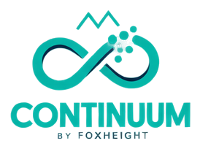
Continuum
By FoxHeight — systems research framework
PLATFORM | RESEARCH

Product Overview

Mission
Continuum is the connective tissue: how twenty product lines, research, and platform services share one engineering foundation.

What it is
Flagship framework for ecosystem mapping, maturity spectrum, and cross-product relations — the map, not a single app.

Core Capabilities
- Ecosystem mapping
- Maturity spectrum communication
- Cross-product relation graph
- Shared platform services catalogue

Use Cases
- Architecture forums
- Maturity reviews
- Partner ecosystem briefings

Technology

Architecture
Layered model from human interfaces through intelligence services to infrastructure and governance. Relations are declared in data, not implied in marketing.

Security Posture
Vision content stays labelled. Speculative diagrams never present as deployed topology.

Ecosystem & Roadmap

Declared Relations
- foxknow SUPPORTS Continuum
- Continuum RESEARCHED BY foxlab
- foxfuture EXTENDS Continuum
- foxlab SUPPORTS Continuum

Open Research Question
How do product graphs stay accurate as lines change maturity without constant manual drift?

Roadmap
Richer graph tooling; keep table accessibility alongside visuals.

Status: Continuum is labelled "research" in the FoxHeight Continuum product registry. This label reflects verified implementation state, not a marketing claim. Source: SOURCE_DATA/products/continuum.json.

