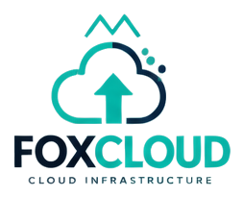
FoxCloud
Cloud infrastructure delivery patterns
INFRASTRUCTURE | PRODUCTION-ADJACENT

Product Overview

Mission
FoxCloud packages hybrid cloud delivery habits — identity boundaries, environment promotion, backup posture — for teams shipping on real hosts.

What it is
Production-adjacent guidance informed by landing-zone style separation. Not a hyperscaler replacement; a delivery discipline layer.

Core Capabilities
- Landing-zone oriented checklists
- Environment promotion models
- Backup and recovery posture notes
- Cost visibility concepts for operators

Use Cases
- Landing-zone reviews
- DR tabletop exercises
- Environment promotion gates

Technology

Architecture
Environments promote deliberately. Identity sits in front of resources. Logs and backups are planned before scale stories.

Security Posture
Secrets stay out of web roots. TLS is assumed at the edge. Admin surfaces remain role-gated.

Ecosystem & Roadmap

Declared Relations
- foxai DEPLOYED ON FoxCloud
- FoxCloud SECURED BY foxshield
- FoxCloud INTEGRATES WITH foxlink
- foxedge EXTENDS FoxCloud
- foxgreen SUPPORTS FoxCloud

Open Research Question
How do regional latency and data-residency rules change promotion pipelines for Kenya-centric deployments?

Roadmap
Deeper cPanel runbooks, then multi-region patterns labelled by maturity.

Status: FoxCloud is labelled "production-adjacent" in the FoxHeight Continuum product registry. This label reflects verified implementation state, not a marketing claim. Source: SOURCE_DATA/products/foxcloud.json.

