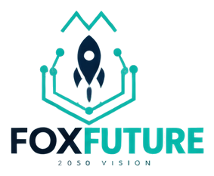
FoxFuture
2050 vision scenarios
VISION | 2050 VISION (CONCEPTUAL)

Product Overview

Mission
FoxFuture holds long-horizon scenarios with radical honesty: vision is labelled vision, evidence is labelled evidence.

What it is
2050-oriented exploration product. Multi-path, uncertain, and never sold as a committed roadmap.

Core Capabilities
- Scenario framing tools
- Horizon maps
- Vision labelling discipline
- Cross-links to Continuum research

Use Cases
- Scenario workshops
- Board horizon sessions
- Research storytelling

Technology

Architecture
Timeline horizons and scenario branches. Each statement carries a tag: evidence, scenario, hypothesis, or vision.

Security Posture
Prevent vision language from leaking into production claims on other product pages.

Ecosystem & Roadmap

Declared Relations
- FoxFuture EXTENDS continuum

Open Research Question
How should organisations plan under deep uncertainty without freezing or over-promising?

Roadmap
Curated scenario packs; still 2050-vision maturity.

Status: FoxFuture is labelled "2050-vision" in the FoxHeight Continuum product registry. This label reflects verified implementation state, not a marketing claim. Source: SOURCE_DATA/products/foxfuture.json.

