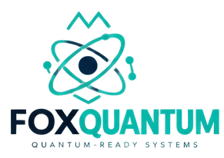
FoxQuantum
Quantum-ready architecture preparation
RESEARCH | CONCEPT

Product Overview

Mission
FoxQuantum prepares vocabulary and hybrid classical–quantum architecture notes — readiness, not hardware ownership theatre.

What it is
Research/concept line for quantum-readiness checklists and algorithm taxonomy. No claim of operating quantum machines.

Core Capabilities
- Quantum-readiness checklists
- Algorithm taxonomy notes
- Hybrid architecture sketches
- Honest limitation statements

Use Cases
- Readiness workshops
- Curriculum for engineering leads

Technology

Architecture
Classical control planes remain primary. Quantum algorithm interfaces are studied as future adapters.

Security Posture
Never imply production quantum capability. Research claims stay scoped.

Ecosystem & Roadmap

Declared Relations
- FoxQuantum RESEARCHED BY foxlab

Open Research Question
Which enterprise problems first justify quantum exploration budgets?

Roadmap
Educational modules and partner research — still concept/research.

Status: FoxQuantum is labelled "concept" in the FoxHeight Continuum product registry. This label reflects verified implementation state, not a marketing claim. Source: SOURCE_DATA/products/foxquantum.json.

